**MULTIPLICATION USING 8086 PROCESSOR**

**Expt:no:35**

**AIM:** To write an assembly language program to implement multiplication using 8086 processor.

**ALGORITHM:**

1. Load the first 16-bit number (num1) into the AX register.

2. Load the second 16-bit number (num2) into the BX register.

3. Use the MUL instruction to multiply the value in the AX register by the value in the BX register.

4. The product will be stored in the DX:AX register pair, with the higher 16 bits in DX and the lower 16 bits in AX.

5. You can then access the result from the DX:AX register pair and use it as needed.

**PROGRAM:**

MOV AL, 2 ; AL = 0C8h

MOV BL, 4

MUL BL ; AX = 0320h (800)

; print result in binary:

MOV bl, al

MOV cx, 8

print: MOV ah, 2 ; print function.

MOV dl, '0'

TEST bl, 10000000b ; test first bit.

JZ zero

MOV dl, '1'

zero: INT 21h

SHL bl, 1

LOOP print

; print binary suffix:

MOV dl, 'b'

INT 21h

; wait for any key press:

MOV ah, 0

INT 16h

RET

**OUTPUT:**

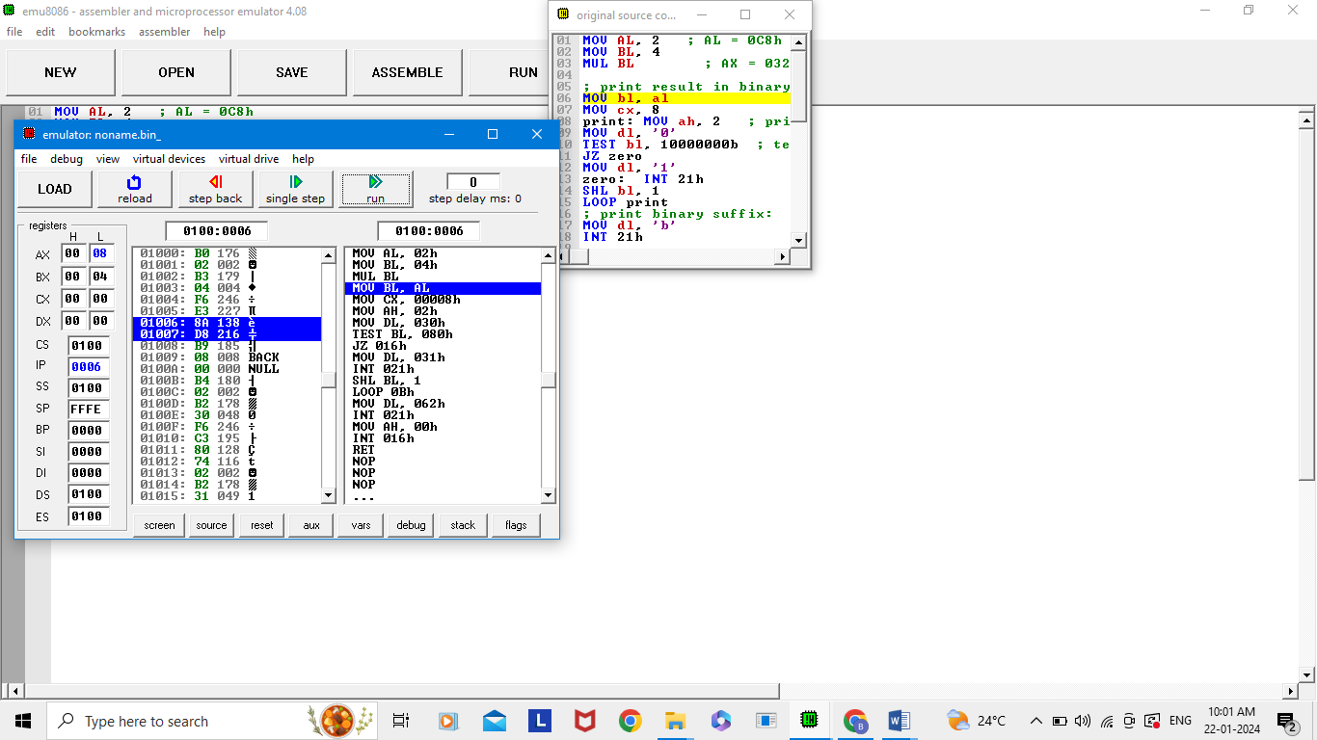

**RESULT:** Thus the program is implemented successfully using 8086 processor.